Salle Boston Club Survey Results -- 10/04/2018

As most of you are aware we recently carried out a survey of club members by Google Forms. This was to work in tandem with various changes we are looking to introduce in order to improve the quality of the training we offer at Salle Boston and many of these new initiatives you will see being introduced over the coming weeks.
Behind all the new initiatives in this survey is a significant amount of effort expended and more than anything we are aware that many members of the club are unaware of how much planning and consideration goes into a lot of what they see, we hope to try and improve upon this but also request that club members attempt to recognise how much gets put in and how they can assist everyone to get the most from their training.
We were delighted with the number of responses we received and it allows us to build up a great picture of what the club needs. We spent nearly 5 hours on Sunday sat talking through all of the responses especially people's suggestions. I won't write a response below to every survey people filled but I hope there will be enough to answer any questions people have. For purpose of brevity I will only be showing the overall responses and not individual groups (e.g. what age groups attend with what regularity etc.).
As always if you have any further questions, or ideas we could consider, please do speak to Tomek, Jon, Matt, Chris or any long standing member of the club or message either on the facebook group chat, email or private message to any relevant person. We are always open to new ideas!
--------------------------------------------------------------------------------------------------------------------------------------
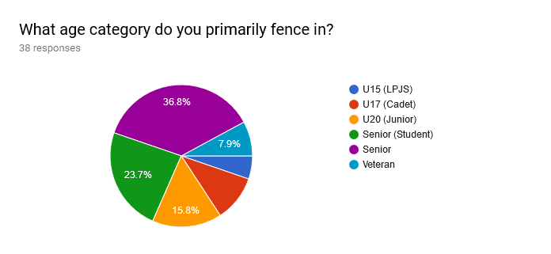
This was just to get a general demographic picture of the club. There aren't many surprises here, the majority of the club members are seniors with a decent proportion being students or under 20s. It is notable that the proportion of Veteran responses are lower than one might think from general club attendance. This may be accurate however may also be due to a combination of lower response rate and less frequent attendance and this has been factored into later data decisions.
--------------------------------------------------------------------------------------------------------------------------------------
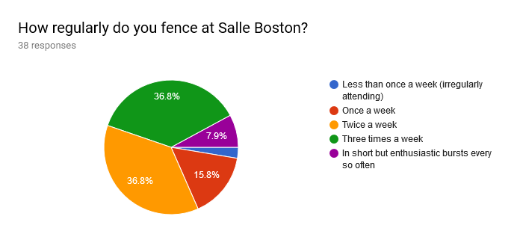
Again it was expected that the highest response rates would come from the most regular attendees. However this does suggest that the majority of stakeholders in any decisions in Boston training are those who attend the most regularly. This informs some of our later decisions going forward on the premise that improvements to training should be targeted towards those who are attending regularly.
--------------------------------------------------------------------------------------------------------------------------------------
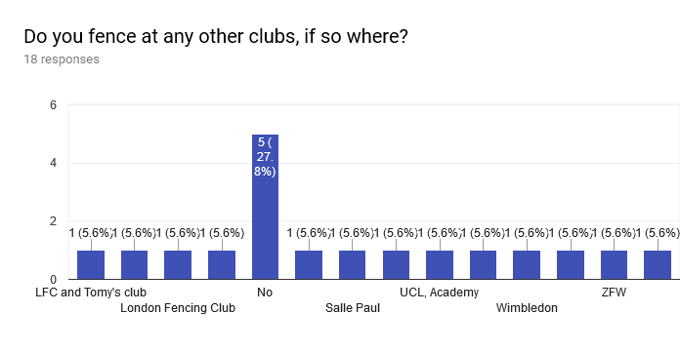
I haven't shown all the responses above because they aren't really relevant but the chart should show the basic point. Part of what makes Boston unique and so good is the fact that we actively welcome fencers from other clubs to enhance and improve on what they get elsewhere. However we also want to ensure the offering we are making is of the highest quality possible. Every member of our club who also trains elsewhere offers us insight into what we can do better. The important information here is that Boston is and should continue to be a melting pot for everyone who wants to get better. Everyone should want to train at the best club in London.
--------------------------------------------------------------------------------------------------------------------------------------
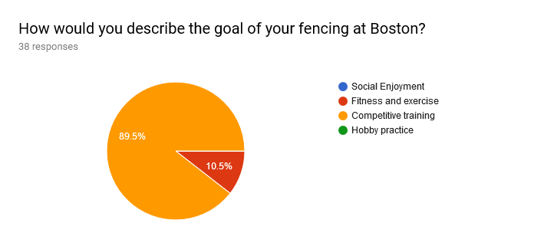
This is one of the more interesting response sets. We wanted to see what people considered the primary reason for their training, we could have asked for a more in depth response relative to the level of fencing or allowed people to choose multiple options but we wanted to see what people considered their major reason.
Overwhelmingly people see their training as being competitive and this matches the general club culture of Boston. This being the case we want to look for as many ways as possible to help develop people's level of fencing regardless of what the starting point maybe.
Overall the message is: people don't just want to fence for fun, they want to get better and get better results. We want to help our members do that.
--------------------------------------------------------------------------------------------------------------------------------------
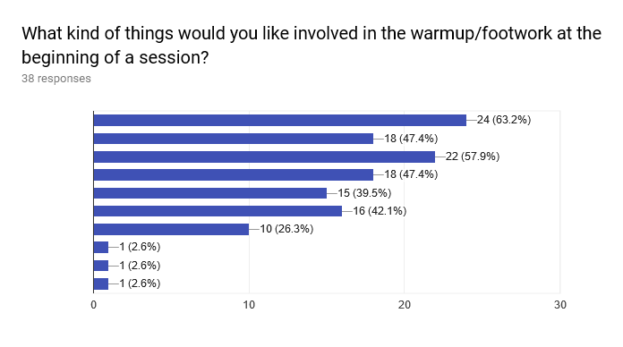
Value | Count
Strength and Conditioning - Fitness related exercise | 24(63.2%)
Plyometric exercises - Jumping, fencing related fitness | 18(47.4%)
Footwork drills - Repetition of combinations of steps, steps up and down etc. | 22(57.9%)
Tactical footwork - Opponent-centric footwork, half step drills etc. | 18(47.4%)
Position drills - Practicing counterattack positions, infighting drills, getting better at fighting when stuff goes bad | 15(39.5%)
Matchcraft - Tactical decisions, decision making in middle, explanation of calls and how to use them etc. | 16(42.1%)
Bladework drills - Blade in hand exercises, applying footwork drills with a blade in hand to make more real | 10(26.3%)
Better warm up before footwork, more dynamic stretching, more runs, more intense runs | 1(2.6%)
Coordination | 1(2.6%)
Reffing decisions explained | 1(2.6%)

This was one of our biggest sections of feedback, we have been experimenting for a while with different ways of laying out the first half hour and have been making it more consistent already. As of a month ago Matt and myself created a new rotation system for footwork which based on this feedback is going to be refined and the basic themes listed below.
Generally there seemed to be interest in all offered options to some level and we believe some of all of them at some point is viable. We will be trying to offer a variation of all options to some level, the frequency is what will vary however.
- Strength and Conditioning and fitness related options were the most popular options, lots of respondents feel this can directly result in an improvement to their fencing which is understandable.
- Next most popular were generic footwork drills. Over recent times we have looked to focus on more timing related and execution based footwork drills. Focussing more on how to execute an action, often more complex than what members may have done previously, however repetition of foot actions to reinforce quality is important too and we will be taking this into account.
- Tactical drills remain popular and will be included.
- Slightly more niche variations see a drop in popularity which is not unexpected and we would look to include these with a lower frequency but still regularity as is needed to introduce skills.
- Matchcraft skills saw general good response. However we trialled a more teaching based skills session (with a laptop looking at attack-on-prep against marches) before the Easter break and got a very positive response so we will be looking to include these kinds of sessions more regularly.

At this stage we were faced with a decision to make. There is clearly demand for S&C of various kinds, however Boston is not a gym and the (volunteer!) fencers who lead the footwork are not qualified fitness instructors. Whilst we can advise and run small sessions ourselves we should not be considered a replacement for proper programs for dedicated athletes.
We also believe that in general philosophy it is not the responsibility of the fencing club to supply the fitness of fencers. Whilst we recognise that not all members are able to regularly attend gyms and may use Boston as their fencing we have to make a decision that if the club is to offer the quality fencing training to those seeking competitive results then it should not be using that time on fitness that can be done outside of sessions.
This does not mean that we will not include fitness as components of the sessions planned. It is our intent to include fitness as a function of footwork within sessions more regularly as well as including sessions on fitness that may not be part of member's general conditioning (e.g. plyometric exercises, coordination exercises etc.).
The conclusion made here however is that it is not the responsibility of the club to provide fitness training in place of specific fencing skill training and the sessions we offer whilst challenging the fitness of athletes will not be carried out for that sole purpose. Indeed as a club primarily for adults and competitive young fencers we believe members are capable of completing their own warmup, stretching and fitness and we would look to supplement, not supply this.

Based on the above we have decided to introduce a consistent footwork planning system which we can use week to week to ensure members receive the benefits of all aspects of this coverage regardless of when they attend training. Generally each of the three themed sessions will be done on each training in a week and will rotate throughout the year, we do not intend to repeat sessions however. We don't ever want to just "go through the motions" of running a session. Every session will broadly be able to categorised into one of:
1) Drills footwork - This is repetition of skills focussing on speed and consistency. We would also introduce fitness based components here primarily.
2) Teaching Footwork - It is tricky to find a title for this however the general theme of this section is areas where we work on developing the quality of a footwork situation. This might be practicing certain footwork with an eye on quality or it may be practicing decision making on steps but is more focused on how to do footwork and so is likely less of the simple stuff
3) Matchcraft - This is the broad idea of "not just footwork" stuff. We don't want to lose coverage of generic footwork training but also want to go above and beyond. This will include tactical sessions, middle action choices, infighting and "unconventional" move choices (when and where to use), theory and decision making, refereeing and how to use it, psychology and much more. We have a lot to offer here but it can't replace the foundation of footwork, just supplement it.
These three sets are just general themes. Within them we can vary the intensity of each session and offer different sessions week to week covering all the suggestions in the survey and more. However we feel using these as scheduled we can ensure that we aren't biasing certain approaches and not others.
This of course is never final and we will adjust this to the needs of members as well as competition schedules and working with coaches to develop the skills we believe are necessary (if you haven't noticed there have been certain foot actions that have been coming up a lot in footwork in recent months. That isn't fluke.).
--------------------------------------------------------------------------------------------------------------------------------------
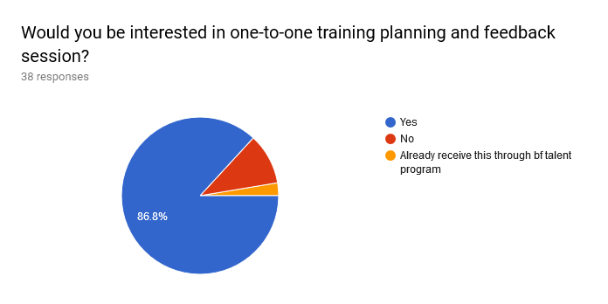
This is an idea we have been mulling over for some time to cover a few shortcomings in the club. Boston has two fantastic coaches who do tons of work to offer high quality lessons to everyone. It is impossible for them however to offer some of the more personalised feedback that a less busy coach could without compromising on the number of people receiving lessons.
However they don't have to be the ones giving it.
The concept behind this will consist of feedback and planning sessions where the coaches would outside of sessions provide information on what an athlete needs to work on, their good points and other notes. These could then be passed on to the athlete at personalised feedback sessions during club nights. We would also sit down with the member to help them plan: what they need to work on, competition planning for the year, athlete development (e.g. S&C and fitness if they need guidance on this) as well as other things. This info and clarification of the athletes goals could then be passed to the coaches who would be able to be kept more up to date on how members are doing whilst also offering the maximum number of lessons.
These would then be updated throughout the year and progress monitored. We hope this will also let us keep in better touch with the needs of our members and avoid offering a "one size fits all" package. Each member of Boston has different needs and different goals, we intend to design a program that helps all members gain this.
We will begin taking signups for the first batch in the first two weeks of Summer term and the program will begin in the second week.
--------------------------------------------------------------------------------------------------------------------------------------
How do you feel about the system of rotating matches? If not how would you change it?
Immediately I should be shot for the awful phrasing of this question. Thankfully most people understood the point of the question.
Generally most people were happy with the format of match rotation on club nights and we intend to stick with it. We do recognise however a need to clarify it so all are on the same page and we intend to do this through a few forums including a more updated website, facebook and a poster on the wall clarifying the format for training nights.
I would put a time limit (eg 10min) to matches as some matches last up to 30 minutes and when there are a lot of people we get to fence only 2 matcher per training

This was a point mentioned a few times. In the past we have experimented with using stopwatches to limit the timing of matches. We have also considered linking to time on the clock and other ideas. We discussed this point for a (very) long time and for the moment have decided to readdress it post-Copenhagen. There are a lot of other changes being introduced to the club and so have decided for the moment this one can wait.
Love it, it’s a fair system, although some updates on current refereeing changes would be good so everybody knows the current rulings.
We will be introducing a whiteboard to the club by the entrance that will carry announcements like this as well as other things. We will also look to include these kind of announcements in start of session announcements.
It’s great unless too many ppl
We will be looking into placing the pistes more efficiently to include more pistes. We will also be repairing/securing more equipment for this.
New safeguarding and health and safety procedures are also being investigated which will coincide with piste spacing discussions.
--------------------------------------------------------------------------------------------------------------------------------------
Do you feel the club is doing a good job? What do we not do well enough?
This is what we all came for!
More physical training rather than just simply footwork and fencing
This is addressed above but we will continue to consider all aspects of how we run training and are always open to discussion. Please speak to us if you feel we may want to reconsider.
Warm up before footwork is almost always very shallow and not effective into actually warming you up, gettin the muscles ready, the joints etc
We agree however a proper warmup realistically takes a minimum of 15 minutes. If we want to do something more with the first half an hour then we can't spend it all warming up. If we choose to spend it all warming up then we can't do more to help develop our fencers.
The conclusion we have come to is that it is the fencers responsibility to arrive and warm up ready to begin before session start. The hall is open and available before the session for this. We also will be looking to more strictly start on time to make full use of our time available.
If we want to make the most of our time, we have to be efficient with it!
More drills, not just footwork - hand is important too - and let’s be honest, it is sometimes impossible to practice certain actions in matches
The opinion of the majority shown above is that they do not wish to do bladework however we agree it is appropriate and for some drills important to train. We will not be focussing on bladework as it is less popular however will include it where appropriate as part of training drills, likely involving kitting up from the start (to use time effectively).
It would be nice if fencers considered fencing opponents of all standard.
This is somewhat covered in our separate clarification of the rotation system, a fencer has the right to choose who they referee after as its their only way to pick matches. They cannot choose who referees after them and so it should be possible for everyone in the club to fence anyone they like. If someone is refusing to fence a member of the club that is absolutely unacceptable and should be reported to the coaches immediately.
Many people don't have time to go to the gym or do a run every week, and so Salle Boston is their main form of exercise.
We understand but this is not our role. If you do fencing and get fit as well that is brilliant but we cannot be required to do the role of fitness trainers in fencing session.
Supply of/active encouragement to get Salle Boston shirts, hoodies, etc. Is currently lacking
The club has several merchandise tops available, however these are not in every size. It is expensive to order these and so not possible without sufficient demand. However we are looking into new design tracksuit tops and will make sure everyone is informed when the next order goes out.
--------------------------------------------------------------------------------------------------------------------------------------
Are there any thoughts or ideas about the club you would like to pass on to us? What could we introduce to be better?
Fencing drills e.g back line training
We will be looking to introduce these once a week, alternately on Wednesdays and Thursdays. These will generally run for the first 30mins to 1 hour and will be different each week possibly linked to the footwork session before sparring. We will look to have these apply for only some hits (e.g. first 5 hits then fence normal for last 10) as we want people to be able to get full fencing normally according to their wishes also. These will be notified on the whiteboard at the session entrance.
However for this to be effective it will require members to support it. If we set a drill and only half the room are doing it then it is a farce and cannot continue. We will need the clubs support to bring in better training.
Maybe more social and fun footworks seshs like the one we had on christmas - or generally, more music at warmup for the first 5-10 min
We'll look into it, the main barrier here is the speaker. If someone has a good speaker that can be loud enough for a hall that they can bring in regularly then we will look into this. Generally more fun sessions we agree.
Maybe once a month an internal club competition
This is too regular but the idea is solid. We will look to do a competition of some form at the end of each half term including a social afterwards of some kind that can include older and younger members (so not just a pub, perhaps the local Nandos).
Maybe more club socials, ie on world cups meet up and watch the second day together
We agree will look into it. We go to the pub after most sessions however and attendance is generally low. All members of the facebook group chat were invited to watch the junior world champs foil and none responded. However we want to do more of this and already have some ideas that will be listed. Boston does not have a social secretary or any of the such however, we're just members who are friends. If you want to host a BBQ and watch the world cup or go bowling or whatever, then do it and tell people!!! The same few people don't have to do everything.
Beer fridge for refreshment between bouts
We'll get on it right away. Only Guinness will be stocked.
It would be fantastic to have somewhere to keep kit.
This is not possible with the school unfortunately but if someone comes up with a new idea we're all ears.
More fit girls
We don't intend to do dedicated S&C however we believe better start times and more intense drill footwork should improve fitness. This should mean the girls and boys of the club should get fitter, so therefore there would be more fit girls.
That's what you meant, right?
Mondays can be shifted to another day or place where we can have a proper fencing space
We are aware that the hall is not quite ideal on a Monday however we are unable to get the other hall. What members should remember is that Boston's continuation is linked to its retention of a good hall space in central London with storage for kit that isn't likely to turf us out in a years time.
The relationship Boston has with the school to keep the hallspace is important. Getting a large hall in central London multiple nights a week at good hours (remember we have the hall on Thurs including junior section from 5.30-10pm. Those are prime hours in a very desirable hall). The hall is extremely expensive but important to the identity of the club.
To have a person with whom one can discuss ref decisions after the tournament (I.e. on Monday or Wednesday night 30 mins after footwork people can go to person X to discuss ref calls)
Christopher Lennon is one of Britains few FIE referees, many of the top fencers in the club also referee regularly around the circuit. They are literally the guys who could referee you at national finals. They are available and always willing and eager to discuss calls. Speak to us! We love talking about fencing!
Sometimes feel that less experienced fencers could be given more strategic advice - perhaps pair each one with a more experienced fencer who can look at what they could be doing to improve.
I agree its nice and we should all aim to do this for our clubmates. Please bear in mind however that every fencer in the club is there to train and get better. The more experience fencers want to train too and they are paying the same fees to do so, it isn't their job to offer advice and we can't expect them to.
Maybe videoing of bouts to aid lesson input
Yes and yes. Please do this, video your competition bouts, the coaches love to see this when you send it to them. Video your clubnight bouts, people have done this regularly in the past, I have, take your phone out give it to a friend in a queue and do it.
--------------------------------------------------------------------------------------------------------------------------------------
So that's all guys. The above doesn't list all we have planned but I thought it important to clarify what we're doing with the information we collected and why.
However we are primarily a club for fencers by fencers. Its your peers who are giving up their time to do the extras beyond simply turning up, jogging around a bit, doing some steps and lunges then fencing for two hours. We want to go above and beyond how good the club already is but it doesn't have to be just the same few people. If you have ideas, we want them. If you can help, please do. And if we can help you, please, tell us how!

